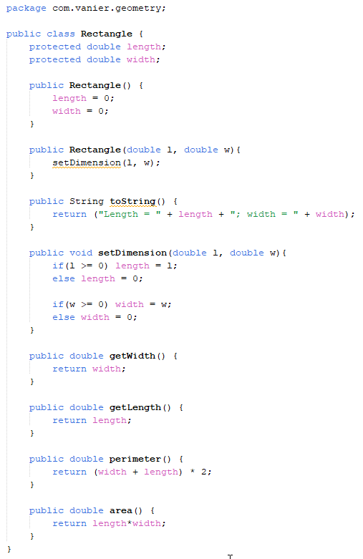

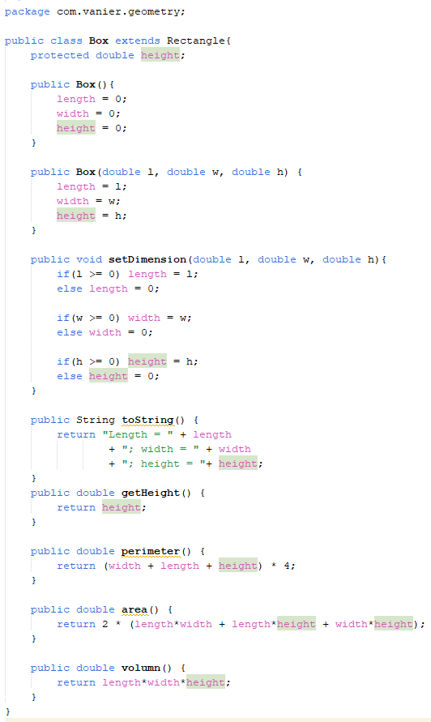

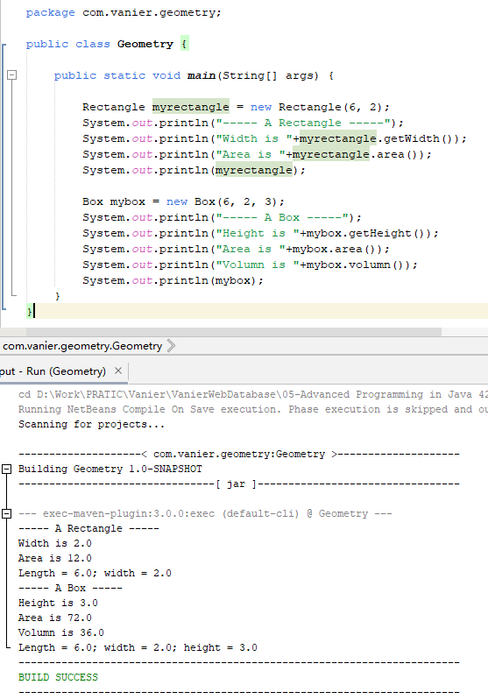

Using your own wording, answer the following questions briefly:

1. What is the purpose of OOP (Object Oriented Programming) and why use we Inheritance in Java?

Answer:

Program is the repeat work, using the process-oriented method requires a lot of repetitive code, and if we considering tasks as objects, the tasks can be logically abstracted, which can greatly save the workload of programming

Because of reusability, adaptability, and robustness, when a large number of similar objects need to be constructed, the inheritance method can be used to derive a new class that is more similar and more suitable for the current task from a higher-level abstract parent class. While inheriting the previous design of the parent class, saving our time.

2. What is the difference between key word ‘extends’ and ‘super’ used in Inheritance?

Answer:

I believed that ‘extends’ is the downwards wildcard, ‘class Child extends Parent’ means class Child bring down some Attributes and Methods from class Parent.

The key word ‘super’ is the upwards wildcard, to obtain and call the Attributes or Methods from upper layer class Parent.

3. How many Data Attributes included in objects of Box class type?

Answer:

I believed that there are 3 Data Attributes: length, width, height. Of which length and width are inherited from Protected attribute of parent class Rectangle, and attribute width is the internal attribute of Class Box.

4. How many Methods declared in the Box class?

Answer:

I designed several public methods

Constructors

public Box()

public Box(double l, double w, double h)

Method Overriding

public void setDimension(double l, double w, double h)

public String toString()

public double perimeter()

public double area()

Method Inherits

public double getWidth()

public double getLength()

Method Defined in subclass

public double getHeight()

public double volumn()

5. Which object has more data attributes Rectangle class (Super class) or Box class (Subclass)?

Answer:

Box class (Subclass) has more data attributes than its Super class Rectangle

6. Given Employee and Person as classes, which one is super class, which one is sub class?

Answer:

Employee should be subclass and inherits from super class Person

Because the employee is a part of person, and has all the characteristics of person.

7. Give an example of super class and sub class as your own project (different than Geometry and Employee/Person) and instantiate one object from super and sub classes.

Answer:

If I design an online shopping mall, I will issue Product as a super class with attributes such as Name, Price, Manufacturer, etc. Then issue sub class Laptop as a subclass with attributes such as CPU, Memory, Hard disk, Graphics Card, etc. at the same time, has these attributes Name, Price, Manufacturer inherited from super class Product.

8. True or false and why: In the definition of class template, which one is valid as per Inheritance?

a. public class Box extends Rectangle

b. public class Rectangle super Box

Answer:

A is correct. Because of Box is a kind of Rectangle, Box has all the attributes and methods of Rectangle, but Rectangle does not include the attributes height and methods volume.